Handel Award of Determination Skill Sheet

Student Name: ______________________________________________ Year: ________________________

In honor of George Fredrick Handel who used his talent to the glory of God and for the good of others. In order to earn this award, you will need to complete and master five basic elements of piano study. You may complete these skills in any order.

- Piano Adventures Method Books:
Complete at least the lesson book for each of the following levels.
Date Completed: Level 4 ____________ Level 5 ____________

2. Theory:
Pass level 7 and level 8 of the Texas State Theory Test. It is not necessary to take the official state test; although, you might consider taking it since you are learning the material anyway.

Date Passed: Level 7 ___________ Level 8 _______________

- Technique:
- We will follow the guidelines for the UT Tyler Piano Skills Festival for the Intermediate Division. Once again, it is not mandatory that you actually participate in the Skills Festival but I highly encourage you to do so.

- Standard Classical Literature:
- You are required to memorize four pieces of standard piano literature from the following list. To help you select and learn your pieces, you may listen to them on YouTube here. Circle your selections below (choose one piece from each time period.)

- Music History:
This is the most creative element of the Musicianship Award. Research the musical time period of one of your performance pieces and present a report. The report should follow similar rules for reports at your school with an introduction, two or three paragraphs of facts about the time period, and a conclusion. Have fun learning more about music history.

Musical Period: ________________________________________Date Completed: ________________________

Chord Positions:

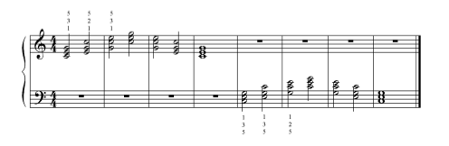
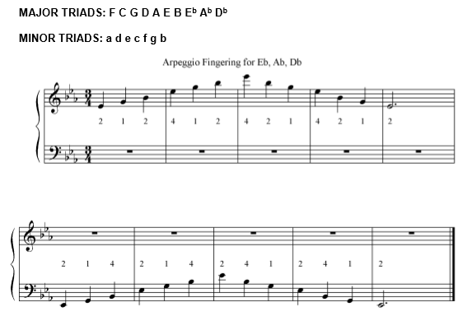
Arpeggios:

Harmonizations:

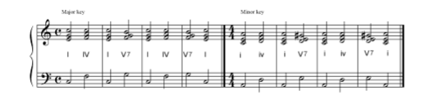

Melodies to Harmonize:
