Mozart Medal of Achievement Skill Sheet

Student Name: ______________________________________________ Year: ________________________

This Musicianship Award is in honor of Wolfgang Amadeus Mozart who was a child prodigy known for his childlike joy of music. In order to earn this award, you will need to complete and master five basic elements of piano study. You may complete these skills in any order. I want you to succeed as much as you do so I will help you every step of the way.

- Piano Adventures Method Books:
Complete at least the lesson book for each of the following levels.

Date Completed: Primer ____________ Level 1 ____________

2. Theory:
Pass level 1 and level 2 of the Texas State Theory Test. It is not necessary to take the official state test; although, you might consider taking it since you are learning the material anyway.

Date Passed: Level 1 ___________ Level 2 ___________

- Technique:
We will follow the guidelines for the UT Tyler Piano Skills Festival for the Elementary Division. Once again, it is not mandatory that you actually participate in the Skills Festival but I highly encourage you to do so.

- Standard Classical Literature:
You are required to memorize at least two pieces of standard piano literature from the following list. To help you select and learn your pieces, you may listen to them on YouTube here. Circle your selections below (try to avoid two pieces from the same time period).

- Music History:
This is the most creative element of the Musicianship Award. Research the composer of your choice or the composer of one of your performance pieces and present a report. The presentation may be a written report (this faux Facebook Page is fun) or an oral report or even a picture. You may make the presentation at your piano lesson, at a piano party or in your music class at school. Have fun learning more about a musical person.

Composer: ________________________________________Date Completed: ________________________

Major and minor 5 finger pattern example:
You need to be able to play this pattern starting on any white key except B.
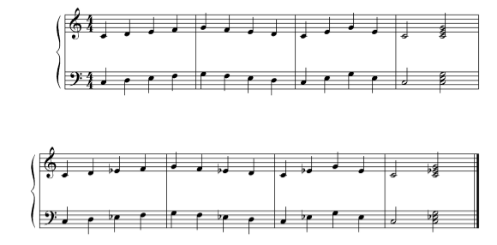

Hand over hand tonic triad example:
You need to be able to play arpeggios starting on any white key except B.
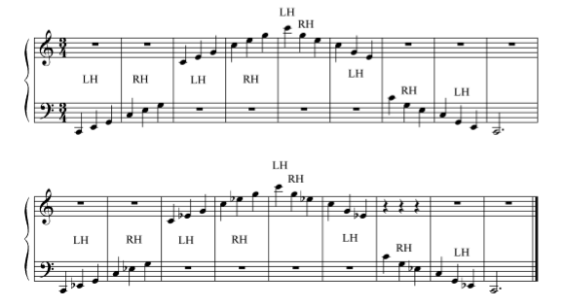

Harmonization example:
You will need to play scales and harmonnizations in the key of C, G, and F major.
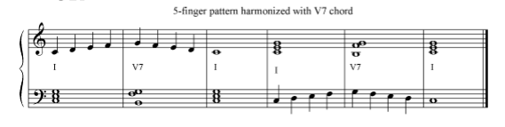

Melodies to harmonize:
You will need to be able to play one of these melodies in the key of C, G, and F major.
